[Cloud Infrastructure & Architecture  |  Google Cloud Training](https://cloud.google.com/training/cloud-infrastructure" \l "cloud-engineer-learning-path)

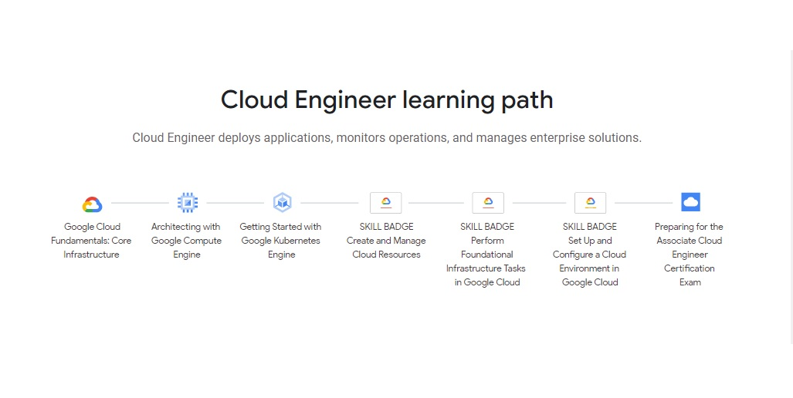

[Google Cloud Platform Fundamentals : Core Infrastructure | Google Cloud Platform Tutorial - YouTube](https://www.youtube.com/watch?v=EjO9nR2_fsQ)

[Large scale and batch computing on Google Compute Engine (Google Cloud Next '17) - Bing video](https://www.bing.com/videos/search?q=Architecting+with+Google+Compute+Engine&&view=detail&mid=11845A60048CC625CCE511845A60048CC625CCE5&&FORM=VRDGAR&ru=%2Fvideos%2Fsearch%3Fq%3DArchitecting%2Bwith%2BGoogle%2BCompute%2BEngine%26FORM%3DHDRSC3)